Poco M2 Pro

Xiaomi owned independent company Poco came in with a surge and announced on Twitter the launch of its Poco M2 Pro on July 7. The Poco M2 Pro India launch event will begin at 12:00 PM IST. After sending media invites, the company has confirmed that launching will be done virtually through its social media platforms. The teaser suggests that Poco M2 Pro will have a quad rear camera setup, with ultra-fast charging.

You can place your order exclusively on Flipkart as it holds the entire market for Poco. Flipkart has also created a unique [advertising microsite](https://www.flipkart.com/poco-m2-pro-di9811-by015-store?affid=HotDeals20&affExtParam2=redpixel&affExtParam1=6872017) revealing a square-shaped quad camera setup (64MP camera, 8MP ultrawide, 5MP macro, and 2MP depth sensor, and with a 16MP selfie camera). The question at the end of the page says if you find the right answer, then you can stand the chance of winning the new Poco phone. The company has kept us in suspicion regarding the other specifications of the phone but is open to assumptions. The designs are still under the veil waiting to be unmasked but will most likely have a punch-hole display.

Revolving around are a few rumors which do make sense after all. Considering the history of Poco tweaking and creating similar spin-offs of Redmi mobile phones, it may have identical features as that of the Redmi Note 9 Pro. Speculations also suggest that the new phone would come with Bluetooth v5.0 as well as dual-band Wi-Fi connectivity options.

Poco M2 Pro scored a 544 in a single-core test, and 1757 in the multi-core test on the Geekbench. So now a few benchmarks and hardware specifications have surfaced, revealing that it'll run on Android 10 OS as expected, powered by Qualcomm octa-core processor with the base frequency of 1.8GHz (processor model rumored to be Qualcomm Snapdragon 720G SoC). The smartphone may also have a 6GB RAM considering the score. With battery capabilities still undiscovered (possibly rated at 5,020mAh or lower), the graphic content released by the company with #FeelTheSurge promises a 33W fast charging support.

The upcoming phone holds a lot of expectations. Will the phone stand out to these speculations? Or will merely be just a cheap rip off of the Redmi Note 9 Pro? To know more, stay tuned and never miss an update.

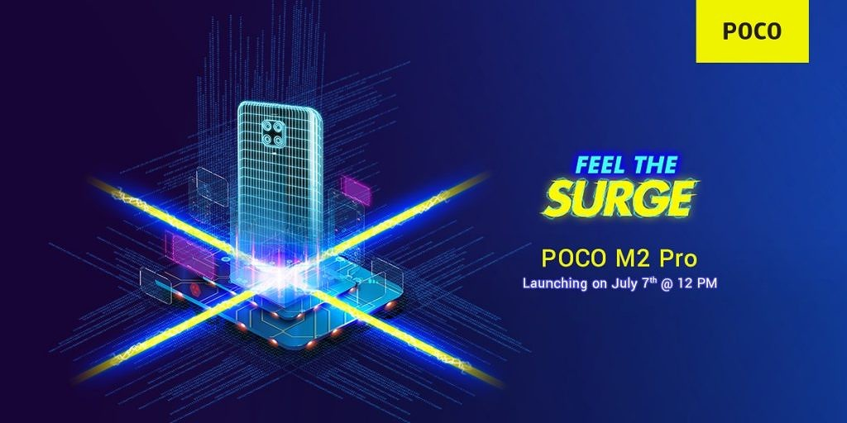

KnowYourGadget

Sarthak Agarwala

7/3/2020